**SOPAS 101**   
For the CLV260-001 Barcode scanner

Connect the scanner to the control module and plug the internet cable in you pc.  
Don’t forget to connect the control module to a 10-30V power supply that can handle 1W.

Install and start up the SOPAS engineering software, you should see this.  
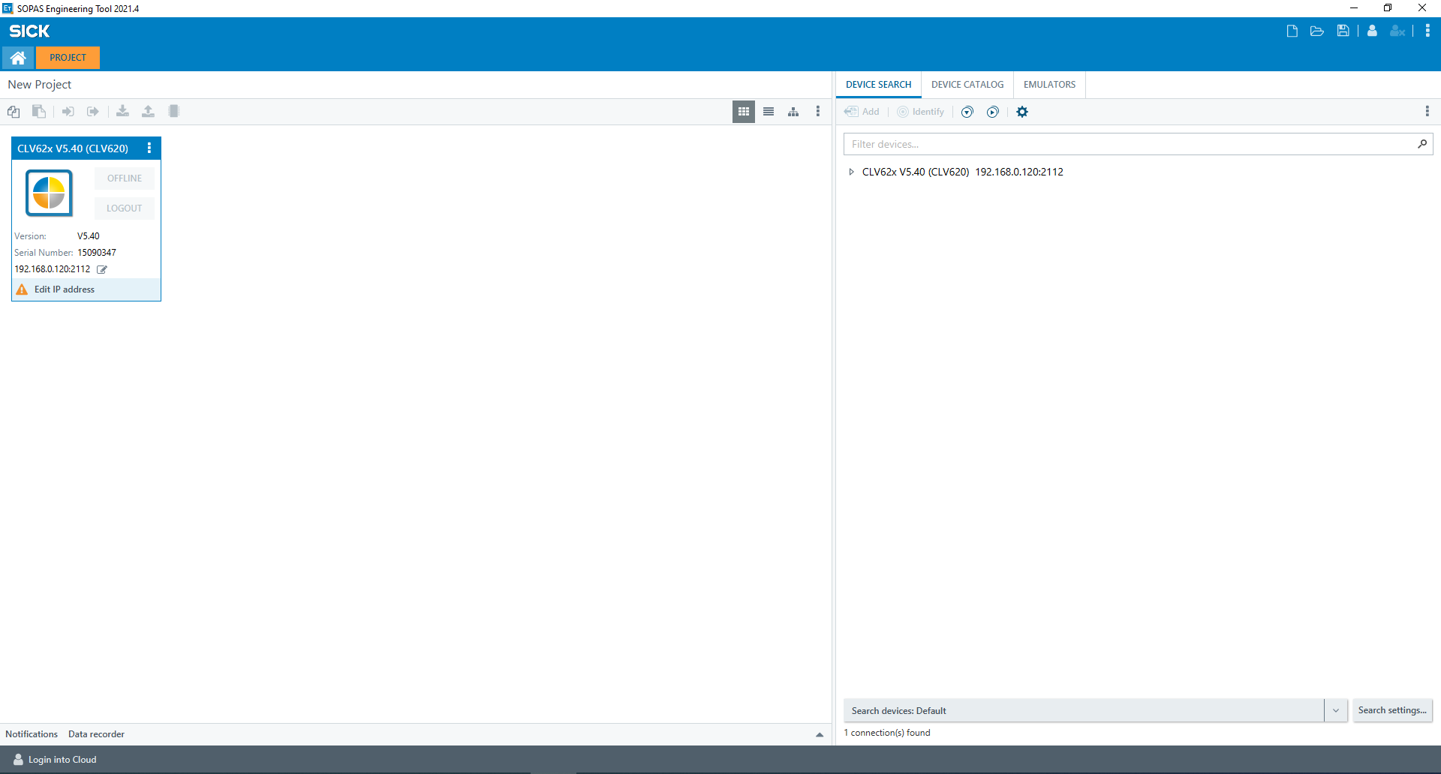  
  
If you don’t get this screen double check your connections and press the “Search devices” button.  
Next you have to configure you Ethernet IP4 address.  
Control Panel>>Network and Internet>>Network and Sharing Center

Make you IP4 match the scanner’s IP EXEPT the last number this has to be differed.  
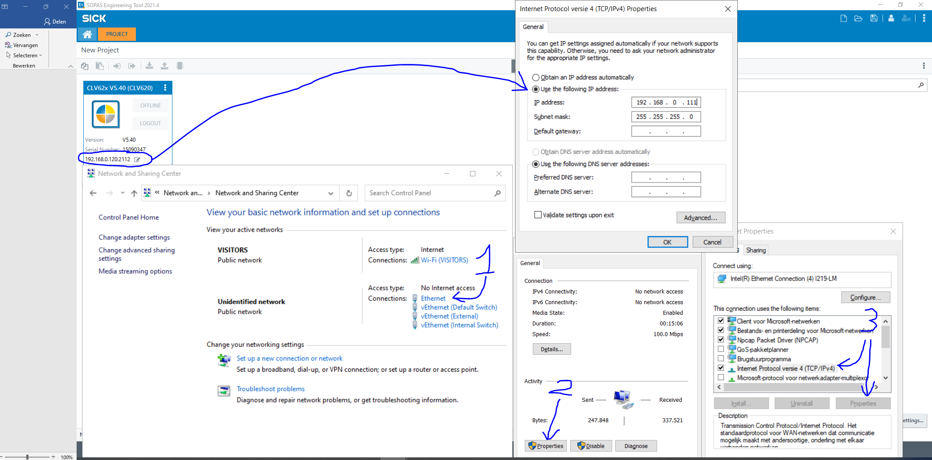

Just press ok when that’s done and you can close all those windows.  
Also close the SOPAS Tool and reopen it, now you should be able to connect by double tapping on the scanner. (Make sure you scanner is online)

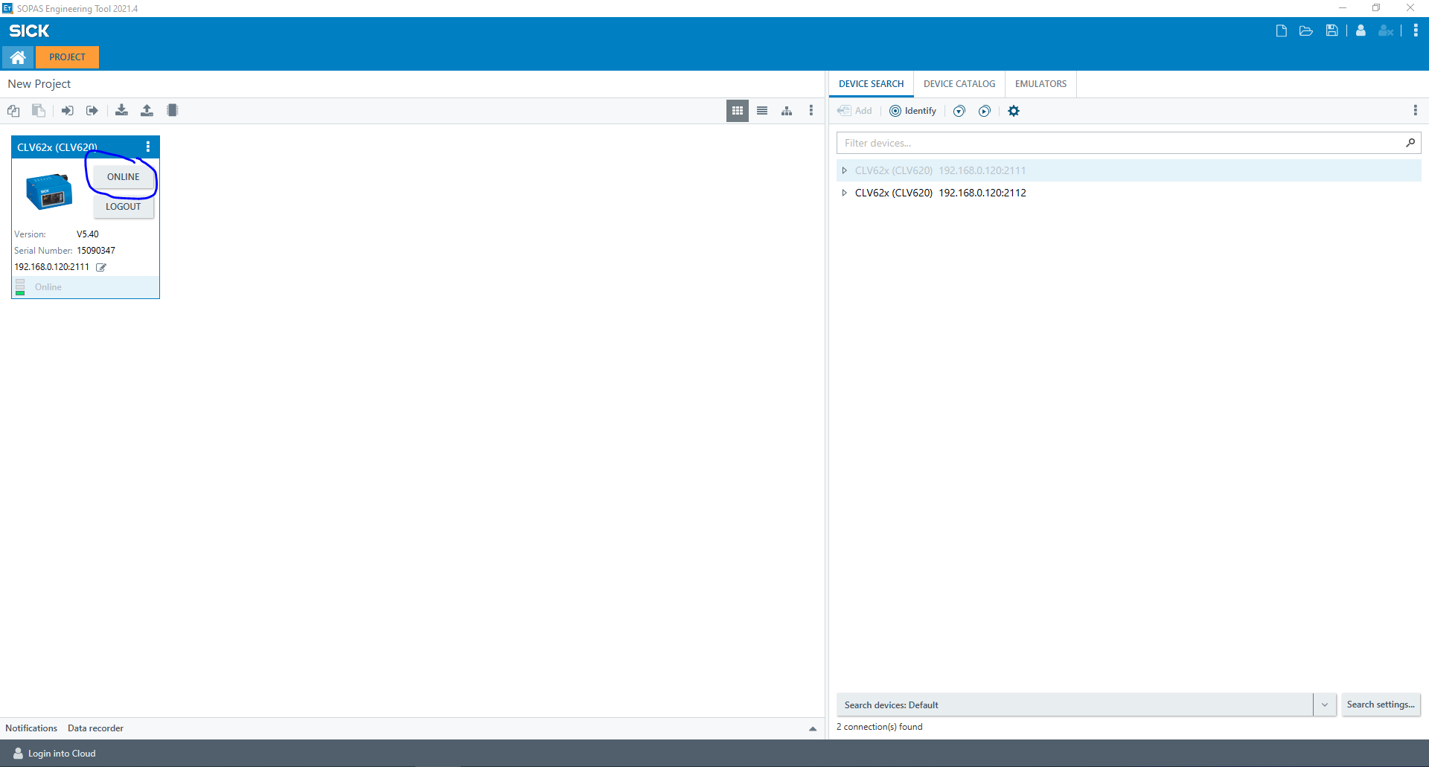

You can test you scanner for the first time using the handy Quickstart , Enabe the type’s of barcodes that you will be scanning and start it. Now the lazer goes on and you can hold a barcode befor it.

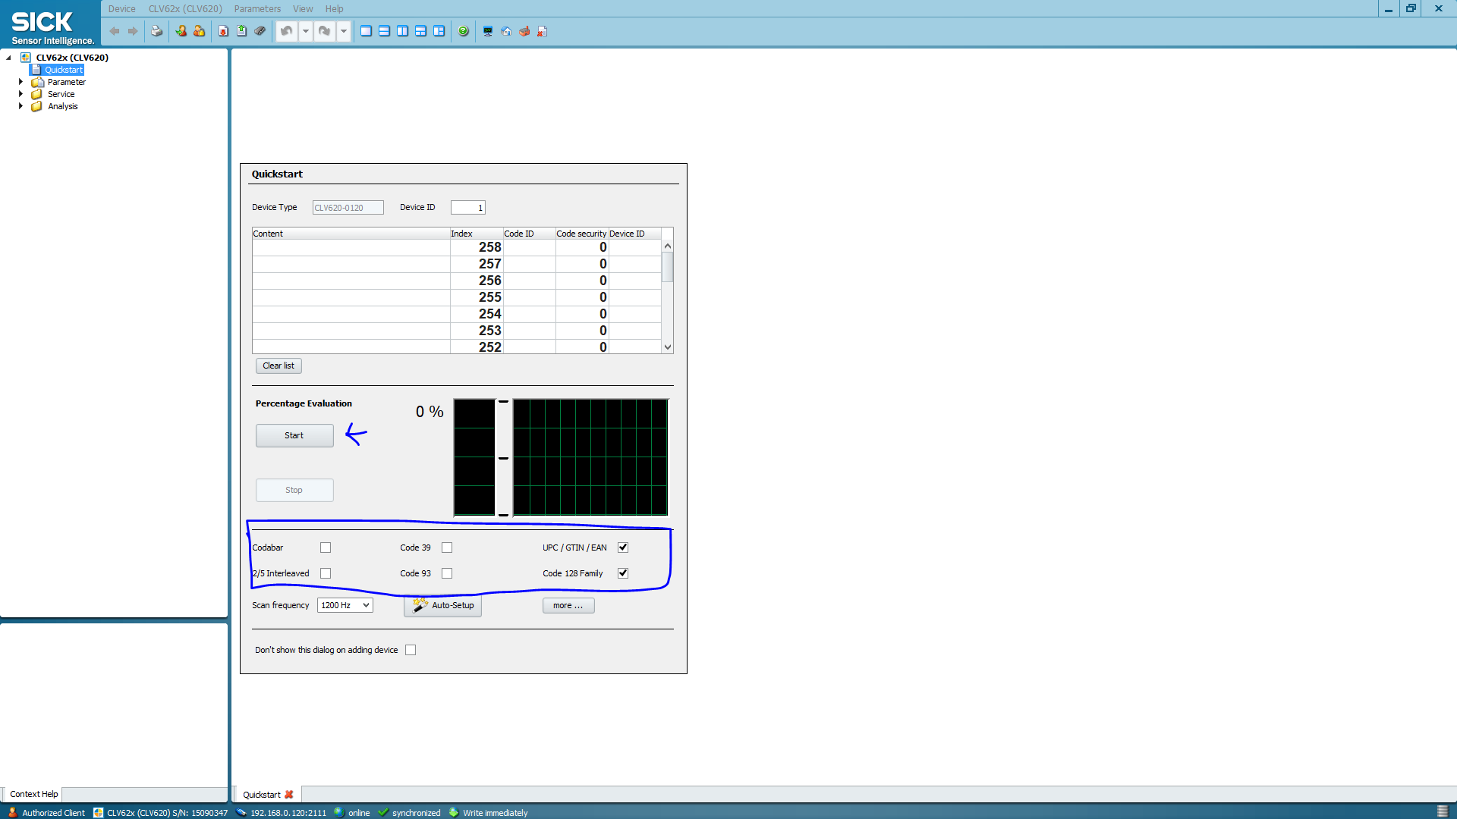

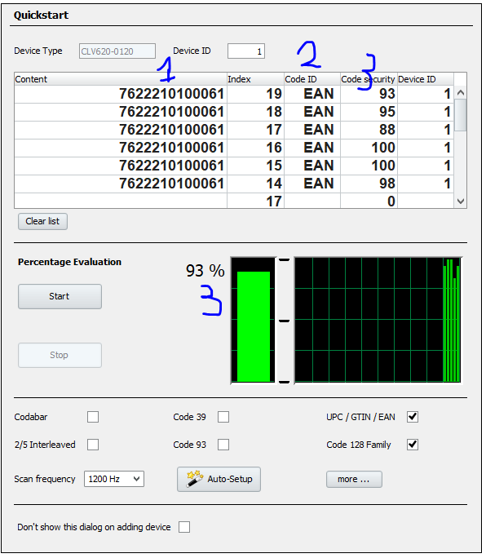If you don’t receive anything try to hold the barcode closer/further away and at a slight angle to avoid reflection going towards the laser.  
  
The information you can find here are.

1: The barcode data (the numbers under the barcode you scanned)

2: what type of barcode

3: The percentage of scans per second are a good read.

If you want to optimize the scan frequency you can do in the auto-Setup.  
It will go from a low speed to the highest speed which still has really good successful read percentage.

This is the end of this document depending on what you want to do with the scanner there will be a follow up document where you can go to.